W3layout:site has lay out temblets

Gethub

New reposatriy

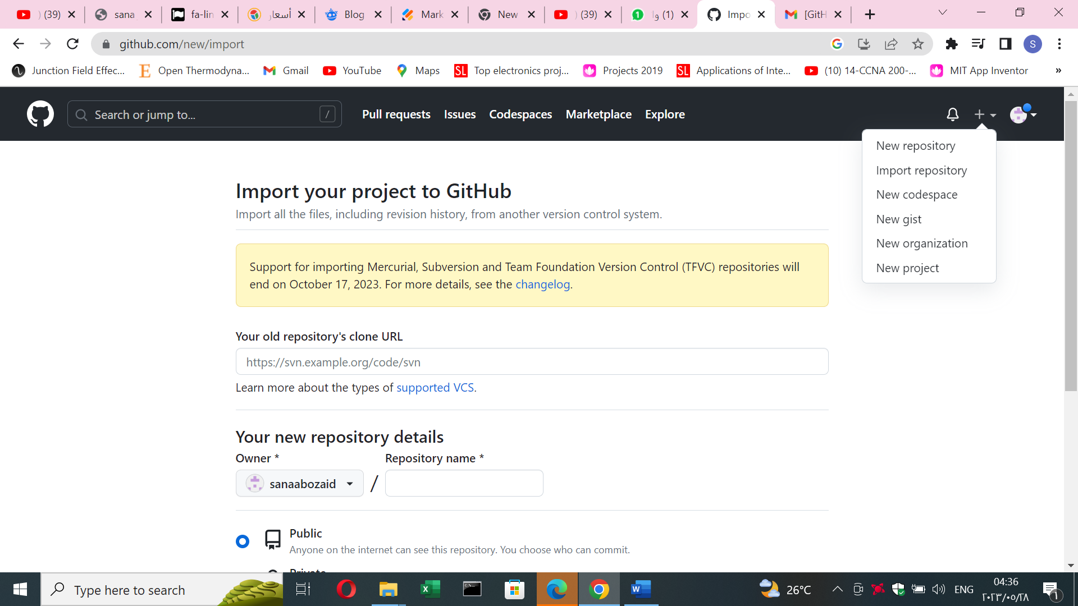

Reposatry means folder

Name it as we like

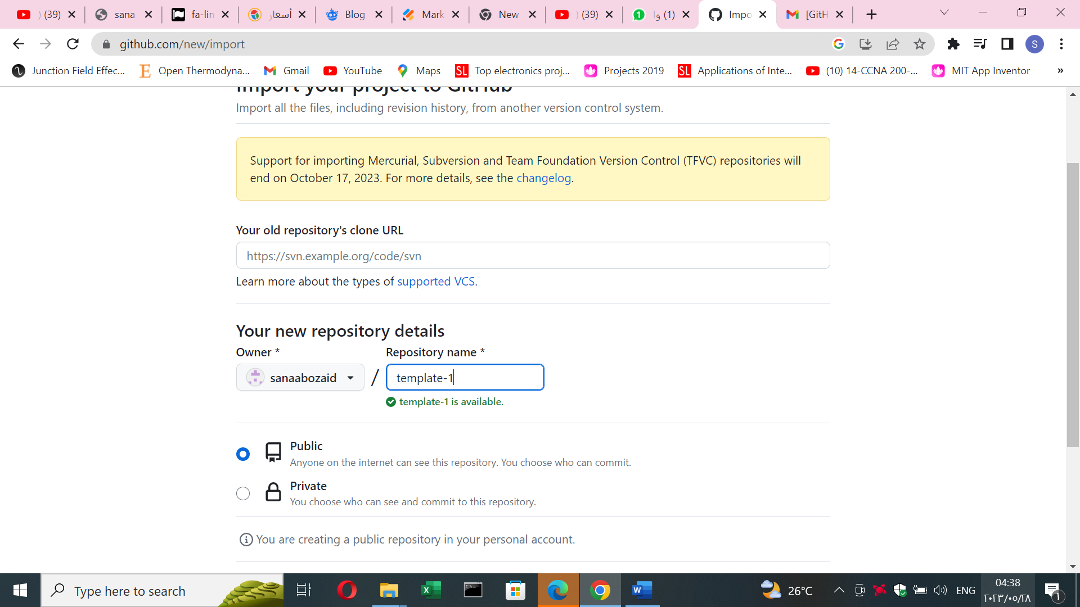

After we name it

2-creat reposatry

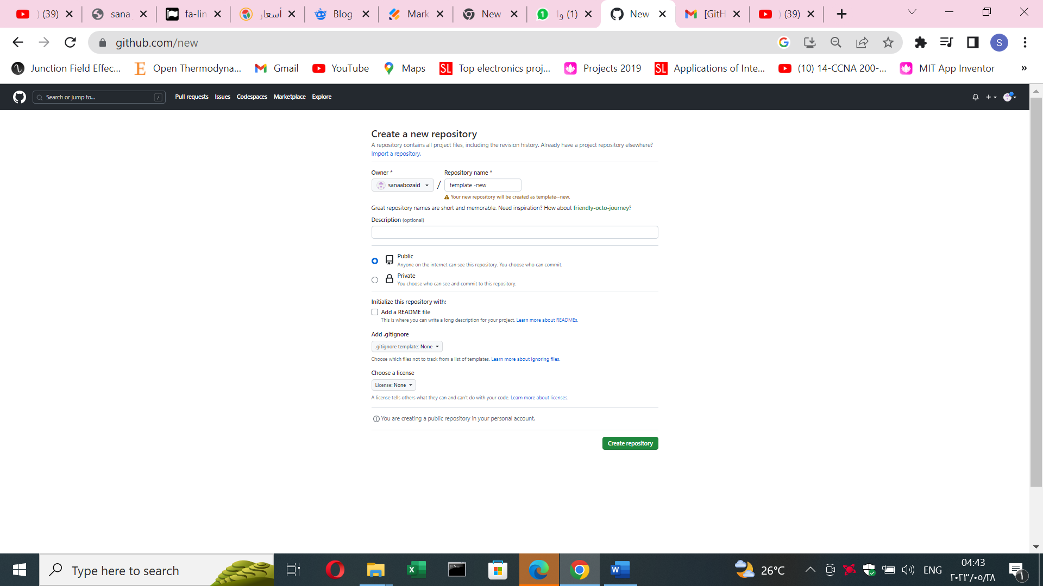

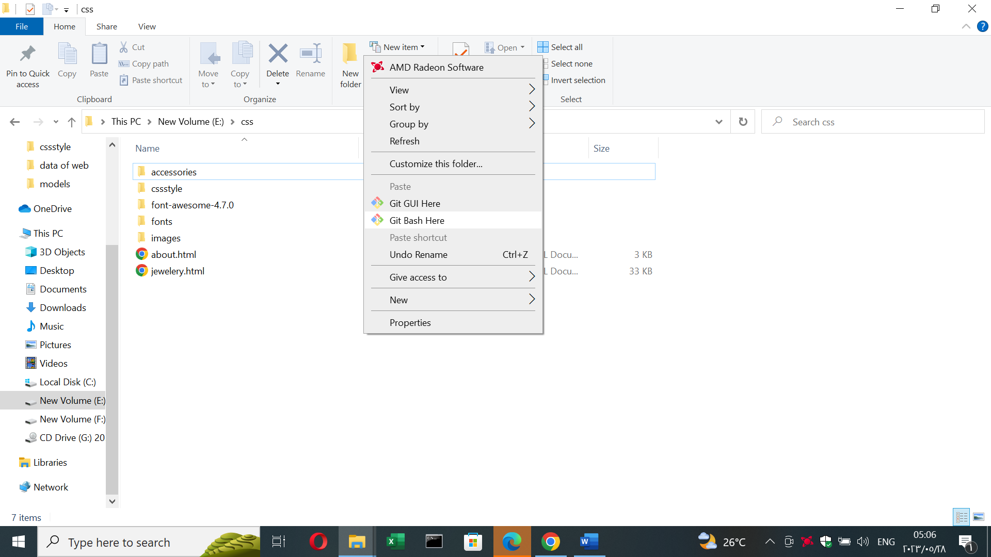

Click at any where in the page

Get bash here

It is the same as cm d but colored

عشان اعرف الجهاز اني هرفع الجهاز وال ال لهف اني هرفع فايل

نفتح

Git

For instialization

Make imaginary folder

Make some codes

1-git init means inslization

2-git add . means every thing I made I want to save it in the pc

3- git commit -m “” means we leave messege what ever we want for next developer between””

Like create project

4- git push origin master means upload the project local to github

5-git remote add origin https://github.com/sanaabozaid/template--new.git

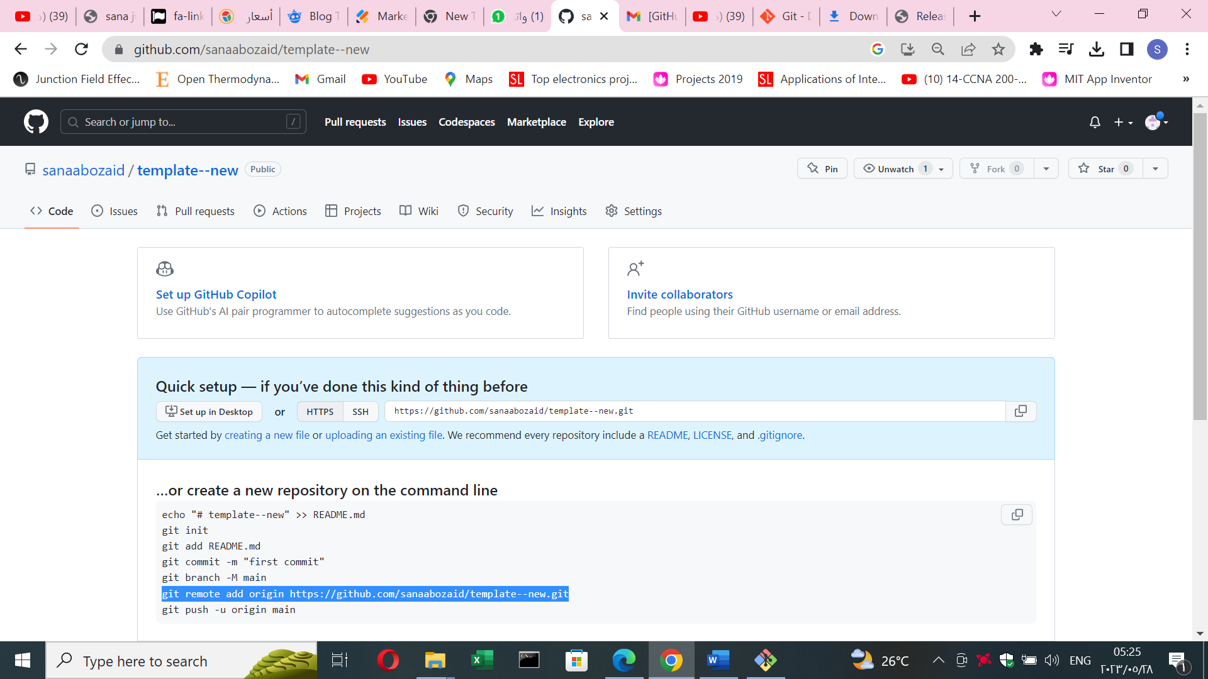

6-git push origin master

